CONTENTS Page No.

1. INTRODUCTION 7
- ORGANISATION PROFILE 8
- PROBLEMS WITH EXISTING SYSTEM 8
- SOLUTIONS TO THESE PROBLEMS 8
- SCOPE OF THE PROJECT 9

2. REQUIREMENT ANALYSIS
- HARWARE REQUIREMENTS 10
- SOFTWARE REQUIREMENTS 10
- SRS DOCUMENT 11
- PROJECT ANALYSIS 12
- FEASIBILITY REPORT 15
- MODULES 16

3. SELECTED SOFTWARE 17
- OVERVIEW OF .NET FRAMEWORK 17
- ASP.NET 25
- C#.NET 31
- SQL SERVER 36

4. SYSTEM DESIGN 40
- DESIGN DOCUMENT 40
- NORMALIZATION 41
- E-R DIAGRAMS 41
- DATA FLOW DIAGRAMS 43
- DATA DICTIONARY 47

5. UML DIAGRAMS 50

6. CODING 55

7. TESTING AND DEBUGGING STRATEGIES 56

8. OUTPUT SCREENS 61

9. CONCLUSION 82

10. BIBLIOGRAPHY 82
1. INTRODUCTION:

ORANISATION PROFILE
Sell Globally is a premier provider of Qualified Professionals to MNC companies and Government Organizations, sell globally has three branches.
The Sell Globally Staffing Group consists of a professional team with strong understanding of dynamic, fast-changing technology environment, and has earned the reputation for finding superior talent who can bring immediate value to the organization. It provides highly professional personnel to meet your short and long term temporary staffing requirements.
Our team consists of the best brains in the industry of HR. They are constantly trained and kept abreast with the latest technologies, various service requirements according to the International Market. Our Team is experienced, vibrant, very consistent to select, identify a best Professional In various Industries.
We have our proven track record, expertise in the following industry / business segments:
IT Enabled Services:

Health Care / Bio Tech Telecom
Banking / Insurance Information Technology
Retail Education

About our Database Server and Maintenance:
- Certified AMP cabling with gigabit backbone
- Switched 100 MB fast Ethernet
- OC3 backbone with public and private peering
- UPS on all systems backed by auto-start dual DG sets
- Microprocessor controlled redundant air conditioning
- Programmable desktop network alerts and audio alarms
- Ultra modern dust-free and anti static environment
- Secure access control
- Smoke detectors and fire fighting systems
- Raised flooring for systematic cabling

PROBLEMS IN THE EXISTING SYSTEM

- The current system is a manual one where in the company maintains all the information in the form of records. There by collecting necessary information with require a manual search in the record(s).
- Transfer of information between different sections of the enterprise is in the form of documents or letters. Drafting letters will take time.
- Selection of a person for a task is done by manually approaching the person and confirming the availability of the person.
- Due to mismanagement the work is delayed to later date than the due date.
- Unavailability of proper information to different levels of employees with in the firm

SOLUTIONS TO THESE PROBLEMS
- The information of the entire firm will be maintained at a centralized data base any changes made by the other departs are known to the higher or lower departments instantly.
- Provide Interactive interface through which a user can interact with different areas of application easily
- Deploy the application on a single system and make is available on all the systems with in the network, there by reducing the maintenance cost of software.
- Notification regarding the task allocation is done via a email which is a part of the application.

SCOPE OF THE PROJECT

- Although the current system is confined to only one firm its performance is limited and restricted to the company. It spans over all the departments which can reach the server from their systems though lan network.
- The application is made as simple as surfing a website. There by non technical persons can also interact with the processing on the application easily.
- Provides instant information regarding the work under process with in the company.
- Easy management of data as located at a server.

2. REQUIREMENT ANALYSIS

HARDWARE REQUIREMENTS:
The hardware used in this project is

- RAM : 256 MB.

- Processor : P-IV Processor

Hard Disk : 20 GB

- Memory :32 MB

SOFTWARE REQUIREMENTS:

The software used in this project is

- Operating System : Windows 2000.

- Software : ASP. Net.

  - Data Base : SQL Server 2000

SRS DOCUMENT:

Intended Audience and Reading suggestions:

The document is prepared keeping is view of the academic constructs of my Bachelors Degree / Masters Degree from university as partial fulfilment of my academic purpose the document specifies the general procedure that that has been followed by me, while the system was studied and developed. The general document was provided by the industry as a reference guide to understand my responsibilities in developing the system, with respect to the requirements that have been pin pointed to get the exact structure of the system as stated by the actual client.
The system as stated by my project leader the actual standards of the specification were desired by conducting a series of interviews and questionnaires. The collected information was organized to form the specification document and then was modeled to suite the standards of the system as intended.

Document Conventions:
The overall document for this project use the recognized modelling standards at the software industries level.
- ER-Modeling to concentrate on the relational states existing upon the system with respect to cardinality.
- The physical dispense , which state the overall data search for the relational key whereas a transactions is implemented on the wear entites
- Unified Modeling Language concepts to give a generalized blue print for the overall system.
- The standards of flow charts at the required states that are the functionality of the operations need more concentration.
Scope of the Development Project:
Database Tier: The concentration is applied by adopting the MS SQL Server 2000.SQL is taken as standard query language.
User Tier: The user interface is developed in a browser specific environment to have distributed architecture. The components are designed using HTML standards and ASP.NET power the dynamic content generation in the page design.
Database Connectivity Tier: The communication architecture is designed by concentrating on the standards of ADO.NET technology for database connectivity.
Role of MS SQL Server 2000:
MS-SQL Server 2000 is one of the many database services that plug into a client/server model. It works efficiently to manage resources, a database information, among the multiple clients requesting and sending.
Structured Query Language (SQL)
SQL is an interactive language used to query the database and access data in a database. SQL has following features.
1. It’s a unified language.
2. It’s a common language for relational database.
3. It’s a non-procedural language.

PROJECT ANALYSIS:

- STUDY OF THE SYSTEM

The complete system can be divided into three halves on basis of access levels.

    - Administrator
    - Manager
Administrator:
An administrator is the main controller of the application. When compared to other types of users an administrator has an additional privilege to create new users manage applications and provide notifications. An administrator creates a new task, evey newly created task is placed in a specific group and is marked with status as open. Using the manage user Assignment the administrator will create of team of an individual person will be allotted with the task to be carried out.
Using the My preferences settings the creator will automatically get notified when ever the created task is changes. It also involves the display settings such as what kind if task list should be displayed whenever the user logs in and the no of tasks that should be shown when the user views the initial page. The preferences settings also includes the sorting of the available tasks based on various parameters, such as task types to display and their respective order. An administrator can also create new category of task lists, into which the future tasks can be placed.
The user management sections involve creating new users and managing existing users in terms of privilege given to them and changing passwords.
Application configuration involves placing the task list category with a status values. The different statuses are open, closed, in progress, intermediate etc.
Notification section includes the mechanism to notify the user with the proper message related to the tasks.

User:
A User is a restricted member of the application where in the user has the privileges to create new tasks manage the tasks and change the status of the application or placement of the application from one category to other category, it doesn’t posses the option of creating new users and management of applications.

ACCESS CONTROL FOR DATA WHICH REQUIRE USER AUTHENTICATION

The following commands specify access control identifiers and they are typically used to authorize and authenticate the user (command codes are
shown in parentheses)

USER NAME (USER)
- The user identification is that which is required by the server for access to its file system. This command will normally be the first command transmitted by the user after the control connections are made (some servers may require this).
PASSWORD (PASS)
- This command must be immediately preceded by the user name command, and, for some sites, completes the user's identification for access control. Since password information is quite sensitive, it is desirable in general to "mask" it or suppress type out.

FEASIBILITY REPORT:
Technical Feasibility:
The total number of databases that were identified to build the system is 13. The major parts of the databases are categorized as administrative components and user based components. The administrative components are useful is managing the actual master date that may be necessary to maintain the consistency of the system. These databases purely used for the internal organizational needs and necessities. The user components are designed to handle to transactional states that arise upon the system where the client makes the visit for the information required to him. The user components are scheduled accept parametrical information from the uses as per the system necessity.
GUI’s:
In the flexibility of the uses the interface has been developed a graphics concept in mind, associated through a browses interface. The GUI’S at the top level have been categorized as
- Administration users interface
- Employer users interface
The Administration users interface concentrate on the consistent in that is practically part of organizational activities and which needs proper authentication for date collation. These interfaces to the visitors with all the transactional states lute date in date deletion and date updation only with the data search capabilities. The employer user interface helps the respective actors in transactions the actual information as per their necessities with specific to the required services. The GUI’s restrict the ordinary users from mismanipulating the systems data, which can make the existing system non operational. The information with specific to their personal standards and strategies can be changed through proper privileges.

Financial Feasibility:
If the administrator or manager has to know about the scheduled tasks, then in manual system a concentrated search has to be done, which is a time consuming process. With the designed database all these overheads are eliminated, making the actual system faster in scheduling the tasks.
In the manual system, a large amount of finances are required to maintain the employees and their jobs. The software used in this project eliminate the investments on the employees. The system over installed and configured makes the overall system to interact with required data exchange and helps the organization in controlling costs there by increasing its profits.
MODULES:
The modules that are identified in this project are
- Administration module
- Task management module
- Task scheduling module
Administration module:
This module maintains the information about information regarding the administrator, employees who are working for the organization. It maintains the communication with the task management module and task scheduling module.

Task management module:
This module generally maintains the information about all the tasks that are organised at the level of organization standards. Any task under the system is registered with this module.

Task scheduling module:
This module maintains information regarding the tasks that are scheduled upon the employees,. It records the date and time when a particular task will be scheduled and by what time the task will be completed.

3. SELECTED SOFTWARE

OVERVIEW OF .NET FRAMEWORK

Microsoft.NET Framework
The .NET Framework is a new computing platform that simplifies application development in the highly distributed environment of the Internet. The .NET Framework is designed to fulfill the following objectives:
- To provide a consistent object-oriented programming environment whether object code is stored and executed locally, executed locally but Internet-distributed, or executed remotely.
- To provide a code-execution environment that minimizes software deployment and versioning conflicts.
- To provide a code-execution environment that guarantees safe execution of code, including code created by an unknown or semi-trusted third party.
- To provide a code-execution environment that eliminates the performance problems of scripted or interpreted environments.
- To make the developer experience consistent across widely varying types of applications, such as Windows-based applications and Web-based applications.
- To build all communication on industry standards to ensure that code based on the .NET Framework can integrate with any other code.
The .NET Framework has two main components: the common language runtime and the .NET Framework class library. The common language runtime is the foundation of the .NET Framework. You can think of the runtime as an agent that manages code at execution time, providing core services such as memory management, thread management, and remoting, while also enforcing strict type safety and other forms of code accuracy that ensure security and robustness. In fact, the concept of code management is a fundamental principle of the runtime. Code that targets the runtime is known as managed code, while code that does not target the runtime is known as unmanaged code. The class library, the other main component of the .NET Framework, is a comprehensive, object-oriented collection of reusable types that you can use to develop applications ranging from traditional command-line or graphical user interface (GUI) applications to applications based on the latest innovations provided by ASP.NET, such as Web Forms and XML Web services.
The .NET Framework can be hosted by unmanaged components that load the common language runtime into their processes and initiate the execution of managed code, thereby creating a software environment that can exploit both managed and unmanaged features. The .NET Framework not only provides several runtime hosts, but also supports the development of third-party runtime hosts.
For example, ASP.NET hosts the runtime to provide a scalable, server-side environment for managed code. ASP.NET works directly with the runtime to enable Web Forms applications and XML Web services, both of which are discussed later in this topic.
Internet Explorer is an example of an unmanaged application that hosts the runtime (in the form of a MIME type extension). Using Internet Explorer to host the runtime enables you to embed managed components or Windows Forms controls in HTML documents. Hosting the runtime in this way makes managed mobile code (similar to Microsoft® ActiveX® controls) possible, but with significant improvements that only managed code can offer, such as semi-trusted execution and secure isolated file storage.
The following illustration shows the relationship of the common language runtime and the class library to your applications and to the overall system. The illustration also shows how managed code operates within a larger architecture.

Features of the Common Language Runtime
The common language runtime manages memory, thread execution, code execution, code safety verification, compilation, and other system services. These features are intrinsic to the managed code that runs on the common language runtime.
With regards to security, managed components are awarded varying degrees of trust, depending on a number of factors that include their origin (such as the Internet, enterprise network, or local computer). This means that a managed component might or might not be able to perform file-access operations, registry-access operations, or other sensitive functions, even if it is being used in the same active application.
The runtime enforces code access security. For example, users can trust that an executable embedded in a Web page can play an animation on screen or sing a song, but cannot access their personal data, file system, or network. The security features of the runtime thus enable legitimate Internet-deployed software to be exceptionally feature rich.
The runtime also enforces code robustness by implementing a strict type- and code-verification infrastructure called the common type system (CTS). The CTS ensures that all managed code is self-describing. The various Microsoft and third-party language compilers generate managed code that conforms to the CTS. This means that managed code can consume other managed types and instances, while strictly enforcing type fidelity and type safety.
In addition, the managed environment of the runtime eliminates many common software issues. For example, the runtime automatically handles object layout and manages references to objects, releasing them when they are no longer being used. This automatic memory management resolves the two most common application errors, memory leaks and invalid memory references.
The runtime also accelerates developer productivity. For example, programmers can write applications in their development language of choice, yet take full advantage of the runtime, the class library, and components written in other languages by other developers. Any compiler vendor who chooses to target the runtime can do so. Language compilers that target the .NET Framework make the features of the .NET Framework available to existing code written in that language, greatly easing the migration process for existing applications.
While the runtime is designed for the software of the future, it also supports software of today and yesterday. Interoperability between managed and unmanaged code enables developers to continue to use necessary COM components and DLLs.
The runtime is designed to enhance performance. Although the common language runtime provides many standard runtime services, managed code is never interpreted. A feature called just-in-time (JIT) compiling enables all managed code to run in the native machine language of the system on which it is executing. Meanwhile, the memory manager removes the possibilities of fragmented memory and increases memory locality-of-reference to further increase performance.
Finally, the runtime can be hosted by high-performance, server-side applications, such as Microsoft® SQL Server™ and Internet Information Services (IIS). This infrastructure enables you to use managed code to write your business logic, while still enjoying the superior performance of the industry's best enterprise servers that support runtime hosting.

.NET Framework Class Library
The .NET Framework class library is a collection of reusable types that tightly integrate with the common language runtime. The class library is object oriented, providing types from which your own managed code can derive functionality. This not only makes the .NET Framework types easy to use, but also reduces the time associated with learning new features of the .NET Framework. In addition, third-party components can integrate seamlessly with classes in the .NET Framework.
For example, the .NET Framework collection classes implement a set of interfaces that you can use to develop your own collection classes. Your collection classes will blend seamlessly with the classes in the .NET Framework.
As you would expect from an object-oriented class library, the .NET Framework types enable you to accomplish a range of common programming tasks, including tasks such as string management, data collection, database connectivity, and file access. In addition to these common tasks, the class library includes types that support a variety of specialized development scenarios. For example, you can use the .NET Framework to develop the following types of applications and services:
- Console applications.
- Scripted or hosted applications.
- Windows GUI applications (Windows Forms).
- ASP.NET applications.
- XML Web services.
- Windows services.
For example, the Windows Forms classes are a comprehensive set of reusable types that vastly simplify Windows GUI development. If you write an ASP.NET Web Form application, you can use the Web Forms classes.

Client Application Development
Client applications are the closest to a traditional style of application in Windows-based programming. These are the types of applications that display windows or forms on the desktop, enabling a user to perform a task. Client applications include applications such as word processors and spreadsheets, as well as custom business applications such as data-entry tools, reporting tools, and so on. Client applications usually employ windows, menus, buttons, and other GUI elements, and they likely access local resources such as the file system and peripherals such as printers.
Another kind of client application is the traditional ActiveX control (now replaced by the managed Windows Forms control) deployed over the Internet as a Web page. This application is much like other client applications: it is executed natively, has access to local resources, and includes graphical elements.
In the past, developers created such applications using C/C++ in conjunction with the Microsoft Foundation Classes (MFC) or with a rapid application development (RAD) environment such as Microsoft® Visual Basic®. The .NET Framework incorporates aspects of these existing products into a single, consistent development environment that drastically simplifies the development of client applications.
The Windows Forms classes contained in the .NET Framework are designed to be used for GUI development. You can easily create command windows, buttons, menus, toolbars, and other screen elements with the flexibility necessary to accommodate shifting business needs.
For example, the .NET Framework provides simple properties to adjust visual attributes associated with forms. In some cases the underlying operating system does not support changing these attributes directly, and in these cases the .NET Framework automatically recreates the forms. This is one of many ways in which the .NET Framework integrates the developer interface, making coding simpler and more consistent.
Unlike ActiveX controls, Windows Forms controls have semi-trusted access to a user's computer. This means that binary or natively executing code can access some of the resources on the user's system (such as GUI elements and limited file access) without being able to access or compromise other resources. Because of code access security, many applications that once needed to be installed on a user's system can now be safely deployed through the Web. Your applications can implement the features of a local application while being deployed like a Web page.

Server Application Development
Server-side applications in the managed world are implemented through runtime hosts. Unmanaged applications host the common language runtime, which allows your custom managed code to control the behavior of the server. This model provides you with all the features of the common language runtime and class library while gaining the performance and scalability of the host server.
The following illustration shows a basic network schema with managed code running in different server environments. Servers such as IIS and SQL Server can perform standard operations while your application logic executes through the managed code.
Server-side managed code
ASP.NET is the hosting environment that enables developers to use the .NET Framework to target Web-based applications. However, ASP.NET is more than just a runtime host; it is a complete architecture for developing Web sites and Internet-distributed objects using managed code. Both Web Forms and XML Web services use IIS and ASP.NET as the publishing mechanism for applications, and both have a collection of supporting classes in the .NET Framework.
XML Web services, an important evolution in Web-based technology, are distributed, server-side application components similar to common Web sites. However, unlike Web-based applications, XML Web services components have no UI and are not targeted for browsers such as Internet Explorer and Netscape Navigator. Instead, XML Web services consist of reusable software components designed to be consumed by other applications, such as traditional client applications, Web-based applications, or even other XML Web services. As a result, XML Web services technology is rapidly moving application development and deployment into the highly distributed environment of the Internet.
If you have used earlier versions of ASP technology, you will immediately notice the improvements that ASP.NET and Web Forms offers. For example, you can develop Web Forms pages in any language that supports the .NET Framework. In addition, your code no longer needs to share the same file with your HTTP text (although it can continue to do so if you prefer). Web Forms pages execute in native machine language because, like any other managed application, they take full advantage of the runtime. In contrast, unmanaged ASP pages are always scripted and interpreted. ASP.NET pages are faster, more functional, and easier to develop than unmanaged ASP pages because they interact with the runtime like any managed application.
The .NET Framework also provides a collection of classes and tools to aid in development and consumption of XML Web services applications. XML Web services are built on standards such as SOAP (a remote procedure-call protocol), XML (an extensible data format), and WSDL ( the Web Services Description Language). The .NET Framework is built on these standards to promote interoperability with non-Microsoft solutions.
For example, the Web Services Description Language tool included with the .NET Framework SDK can query an XML Web service published on the Web, parse its WSDL description, and produce C# or Visual Basic source code that your application can use to become a client of the XML Web service. The source code can create classes derived from classes in the class library that handle all the underlying communication using SOAP and XML parsing. Although you can use the class library to consume XML Web services directly, the Web Services Description Language tool and the other tools contained in the SDK facilitate your development efforts with the .NET Framework.
If you develop and publish your own XML Web service, the .NET Framework provides a set of classes that conform to all the underlying communication standards, such as SOAP, WSDL, and XML. Using those classes enables you to focus on the logic of your service, without concerning yourself with the communications infrastructure required by distributed software development.
Finally, like Web Forms pages in the managed environment, your XML Web service will run with the speed of native machine language using the scalable communication of IIS. Active Server Pages.NET(ASP.NET):
ASP.NET is a programming framework built on the common language runtime that can be used on a server to build powerful Web applications. ASP.NET offers several important advantages over previous Web development models:
- Enhanced Performance. ASP.NET is compiled common language runtime code running on the server. Unlike its interpreted predecessors, ASP.NET can take advantage of early binding, just-in-time compilation, native optimization, and caching services right out of the box. This amounts to dramatically better performance before you ever write a line of code.
- World-Class Tool Support. The ASP.NET framework is complemented by a rich toolbox and designer in the Visual Studio integrated development environment. WYSIWYG editing, drag-and-drop server controls, and automatic deployment are just a few of the features this powerful tool provides.
- Power and Flexibility. Because ASP.NET is based on the common language runtime, the power and flexibility of that entire platform is available to Web application developers. The .NET Framework class library, Messaging, and Data Access solutions are all seamlessly accessible from the Web. ASP.NET is also language-independent, so you can choose the language that best applies to your application or partition your application across many languages. Further, common language runtime interoperability guarantees that your existing investment in COM-based development is preserved when migrating to ASP.NET.
- Simplicity. ASP.NET makes it easy to perform common tasks, from simple form submission and client authentication to deployment and site configuration. For example, the ASP.NET page framework allows you to build user interfaces that cleanly separate application logic from presentation code and to handle events in a simple, Visual Basic - like forms processing model. Additionally, the common language runtime simplifies development, with managed code services such as automatic reference counting and garbage collection.
- Manageability. ASP.NET employs a text-based, hierarchical configuration system, which simplifies applying settings to your server environment and Web applications. Because configuration information is stored as plain text, new settings may be applied without the aid of local administration tools. This "zero local administration" philosophy extends to deploying ASP.NET Framework applications as well. An ASP.NET Framework application is deployed to a server simply by copying the necessary files to the server. No server restart is required, even to deploy or replace running compiled code.
- Scalability and Availability. ASP.NET has been designed with scalability in mind, with features specifically tailored to improve performance in clustered and multiprocessor environments. Further, processes are closely monitored and managed by the ASP.NET runtime, so that if one misbehaves (leaks, deadlocks), a new process can be created in its place, which helps keep your application constantly available to handle requests.
- Customizability and Extensibility. ASP.NET delivers a well-factored architecture that allows developers to "plug-in" their code at the appropriate level. In fact, it is possible to extend or replace any subcomponent of the ASP.NET runtime with your own custom-written component. Implementing custom authentication or state services has never been easier.
- Security. With built in Windows authentication and per-application configuration, you can be assured that your applications are secure.

Language Support

The Microsoft .NET Platform currently offers built-in support for three languages: C#, Visual Basic, and JScript.

What is ASP.NET Web Forms?
The ASP.NET Web Forms page framework is a scalable common language runtime programming model that can be used on the server to dynamically generate Web pages.
Intended as a logical evolution of ASP (ASP.NET provides syntax compatibility with existing pages), the ASP.NET Web Forms framework has been specifically designed to address a number of key deficiencies in the previous model. In particular, it provides:
- The ability to create and use reusable UI controls that can encapsulate common functionality and thus reduce the amount of code that a page developer has to write.
- The ability for developers to cleanly structure their page logic in an orderly fashion (not "spaghetti code").
- The ability for development tools to provide strong WYSIWYG design support for pages (existing ASP code is opaque to tools).
ASP.NET Web Forms pages are text files with an .aspx file name extension. They can be deployed throughout an IIS virtual root directory tree. When a browser client requests .aspx resources, the ASP.NET runtime parses and compiles the target file into a .NET Framework class. This class can then be used to dynamically process incoming requests. (Note that the .aspx file is compiled only the first time it is accessed; the compiled type instance is then reused across multiple requests).
An ASP.NET page can be created simply by taking an existing HTML file and changing its file name extension to .aspx (no modification of code is required). For example, the following sample demonstrates a simple HTML page that collects a user's name and category preference and then performs a form postback to the originating page when a button is clicked:
ASP.NET provides syntax compatibility with existing ASP pages. This includes support for <% %> code render blocks that can be intermixed with HTML content within an .aspx file. These code blocks execute in a top-down manner at page render time.
Code-Behind Web Forms
ASP.NET supports two methods of authoring dynamic pages. The first is the method shown in the preceding samples, where the page code is physically declared within the originating .aspx file. An alternative approach--known as the code-behind method--enables the page code to be more cleanly separated from the HTML content into an entirely separate file.
Introduction to ASP.NET Server Controls
In addition to (or instead of) using <% %> code blocks to program dynamic content, ASP.NET page developers can use ASP.NET server controls to program Web pages. Server controls are declared within an .aspx file using custom tags or intrinsic HTML tags that contain a runat="server" attribute value. Intrinsic HTML tags are handled by one of the controls in the System.Web.UI.HtmlControls namespace. Any tag that doesn't explicitly map to one of the controls is assigned the type of System.Web.UI.HtmlControls.HtmlGenericControl.
Server controls automatically maintain any client-entered values between round trips to the server. This control state is not stored on the server (it is instead stored within an <input type="hidden"> form field that is round-tripped between requests). Note also that no client-side script is required.
In addition to supporting standard HTML input controls, ASP.NET enables developers to utilize richer custom controls on their pages. For example, the following sample demonstrates how the <asp:adrotator> control can be used to dynamically display rotating ads on a page.
- ASP.NET Web Forms provide an easy and powerful way to build dynamic Web UI.
- ASP.NET Web Forms pages can target any browser client (there are no script library or cookie requirements).
- ASP.NET Web Forms pages provide syntax compatibility with existing ASP pages.
- ASP.NET server controls provide an easy way to encapsulate common functionality.
- ASP.NET ships with 45 built-in server controls. Developers can also use controls built by third parties.
- ASP.NET server controls can automatically project both uplevel and downlevel HTML.
- ASP.NET templates provide an easy way to customize the look and feel of list server controls.
- ASP.NET validation controls provide an easy way to do declarative client or server data validation.
Crystal Reports
Crystal Reports for Visual Basic .NET is the standard reporting tool for Visual Basic.NET; it brings the ability to create interactive, presentation-quality content — which has been the strength of Crystal Reports for years — to the .NET platform.
With Crystal Reports for Visual Basic.NET, you can host reports on Web and Windows platforms and publish Crystal reports as Report Web Services on a Web server.
To present data to users, you could write code to loop through recordsets and print them inside your Windows or Web application. However, any work beyond basic formatting can be complicated: consolidations, multiple level totals, charting, and conditional formatting are difficult to program.
With Crystal Reports for Visual Studio .NET, you can quickly create complex and professional-looking reports. Instead of coding, you use the Crystal Report Designer interface to create and format the report you need. The powerful Report Engine processes the formatting, grouping, and charting criteria you specify.
Report Experts
Using the Crystal Report Experts, you can quickly create reports based on your development needs:
- Choose from report layout options ranging from standard reports to form letters, or build your own report from scratch.
- Display charts that users can drill down on to view detailed report data.
- Calculate summaries, subtotals, and percentages on grouped data.
- Show TopN or BottomN results of data.
- Conditionally format text and rotate text objects.
Asp.net supports normal web application, mobile web application, Ajax.

ASP.NET web page consists of two pages:
- Visual elements, which include html markup tags and static text.

- Programming logic for the page, this includes event handlers and other code.

ASP.NET provides two models:
- Single file page model.
- Code-behind page model
HTML controls for ASP.NET web pages:
- Div
- Horizontal rule
- Image
- Input
- Select
- Table
- Text area

ASP.NET web server controls
- Html server controls
- Web server controls
- Validation controls
- User controls
ASP.NET 2.0 features:
- 50 new controls
- Master pages

C#.NET

ADO.NET Overview (ACTIVE X DATA OBJECTS.NET):
ADO.NET is an evolution of the ADO data access model that directly addresses user requirements for developing scalable applications. It was designed specifically for the web with scalability, statelessness, and XML in mind.
ADO.NET uses some ADO objects, such as the Connection and Command objects, and also introduces new objects. Key new ADO.NET objects include the DataSet, DataReader, and DataAdapter.
The important distinction between this evolved stage of ADO.NET and previous data architectures is that there exists an object -- the DataSet -- that is separate and distinct from any data stores. Because of that, the DataSet functions as a standalone entity. You can think of the DataSet as an always disconnected recordset that knows nothing about the source or destination of the data it contains. Inside a DataSet, much like in a database, there are tables, columns, relationships, constraints, views, and so forth.
A DataAdapter is the object that connects to the database to fill the DataSet. Then, it connects back to the database to update the data there, based on operations performed while the DataSet held the data. In the past, data processing has been primarily connection-based. Now, in an effort to make multi-tiered apps more efficient, data processing is turning to a message-based approach that revolves around chunks of information. At the center of this approach is the DataAdapter, which provides a bridge to retrieve and save data between a DataSet and its source data store. It accomplishes this by means of requests to the appropriate SQL commands made against the data store.
The XML-based DataSet object provides a consistent programming model that works with all models of data storage: flat, relational, and hierarchical. It does this by having no 'knowledge' of the source of its data, and by representing the data that it holds as collections and data types. No matter what the source of the data within the DataSet is, it is manipulated through the same set of standard APIs exposed through the DataSet and its subordinate objects.
While the DataSet has no knowledge of the source of its data, the managed provider has detailed and specific information. The role of the managed provider is to connect, fill, and persist the DataSet to and from data stores. The OLE DB and SQL Server .NET Data Providers (System.Data.OleDb and System.Data.SqlClient) that are part of the .Net Framework provide four basic objects: the Command, Connection, DataReader and DataAdapter. In the remaining sections of this document, we'll walk through each part of the DataSet and the OLE DB/SQL Server .NET Data Providers explaining what they are, and how to program against them.
The following sections will introduce you to some objects that have evolved, and some that are new. These objects are:
- Connections. For connection to and managing transactions against a database.
- Commands. For issuing SQL commands against a database.
- DataReaders. For reading a forward-only stream of data records from a SQL Server data source.
- DataSets. For storing, remoting and programming against flat data, XML data and relational data.
- DataAdapters. For pushing data into a DataSet, and reconciling data against a database.
When dealing with connections to a database, there are two different options: SQL Server .NET Data Provider (System.Data.SqlClient) and OLE DB .NET Data Provider (System.Data.OleDb). In these samples we will use the SQL Server .NET Data Provider. These are written to talk directly to Microsoft SQL Server. The OLE DB .NET Data Provider is used to talk to any OLE DB provider (as it uses OLE DB underneath).
Connections
Connections are used to 'talk to' databases, and are represented by provider-specific classes such as SQLConnection. Commands travel over connections and resultsets are returned in the form of streams which can be read by a DataReader object, or pushed into a DataSet object.
Commands
Commands contain the information that is submitted to a database, and are represented by provider-specific classes such as SQLCommand. A command can be a stored procedure call, an UPDATE statement, or a statement that returns results. You can also use input and output parameters, and return values as part of your command syntax. The example below shows how to issue an INSERT statement against the Northwind database.

DataReaders
The DataReader object is somewhat synonymous with a read-only/forward-only cursor over data. The DataReader API supports flat as well as hierarchical data. A DataReader object is returned after executing a command against a database. The format of the returned DataReader object is different from a recordset. For example, you might use the DataReader to show the results of a search list in a web page.
DataSets and DataAdapters
DataSets
The DataSet object is similar to the ADO Recordset object, but more powerful, and with one other important distinction: the DataSet is always disconnected. The DataSet object represents a cache of data, with database-like structures such as tables, columns, relationships, and constraints. However, though a DataSet can and does behave much like a database, it is important to remember that DataSet objects do not interact directly with databases, or other source data. This allows the developer to work with a programming model that is always consistent, regardless of where the source data resides. Data coming from a database, an XML file, from code, or user input can all be placed into DataSet objects. Then, as changes are made to the DataSet they can be tracked and verified before updating the source data. The Getchanges method of the DataSet object actually creates a second Dataset that contains only the changes to the data. This DataSet is then used by a DataAdapter (or other objects) to update the original data source.
The DataSet has many XML characteristics, including the ability to produce and consume XML data and XML schemas. XML schemas can be used to describe schemas interchanged via Web Services. In fact, a DataSet with a schema can actually be compiled for type safety and statement completion.

DataAdapters (OLEDB/SQL)
The DataAdapter object works as a bridge between the DataSet and the source data. Using the provider-specific SqlDataAdapter (along with its associated SqlCommand and SqlConnection) can increase overall performance when working with a Microsoft SQL Server databases. For other OLE DB-supported databases, you would use the OleDbDataAdapter object and its associated OleDbCommand and OleDbConnection objects.
The DataAdapter object uses commands to update the data source after changes have been made to the DataSet. Using the Fill method of the DataAdapter calls the SELECT command; using the Update method calls the INSERT, UPDATE or DELETE command for each changed row. You can explicitly set these commands in order to control the statements used at runtime to resolve changes, including the use of stored procedures. For ad-hoc scenarios, a CommandBuilder object can generate these at run-time based upon a select statement. However, this run-time generation requires an extra round-trip to the server in order to gather required metadata, so explicitly providing the INSERT, UPDATE, and DELETE commands at design time will result in better run-time performance.
- ADO.NET is the next evolution of ADO for the .Net Framework.
- ADO.NET was created with n-Tier, statelessness and XML in the forefront. Two new objects, the DataSet and DataAdapter, are provided for these scenarios.
- ADO.NET can be used to get data from a stream, or to store data in a cache for updates.
- There is a lot more information about ADO.NET in the documentation.
- Remember, you can execute a command directly against the database in order to do inserts, updates, and deletes. You don't need to first put data into a DataSet in order to insert, update, or delete it.
- Also, you can use a DataSet to bind to the data, move through the data, and navigate data relationships

SQL SERVER

DATABASE

A database management, or DBMS, gives the user access to their data and helps them transform the data into information. Such database management systems include dBase, paradox, IMS, SQL Server and SQL Server. These systems allow users to create, update and extract information from their database.
A database is a structured collection of data. Data refers to the characteristics of people, things and events. SQL Server stores each data item in its own fields. In SQL Server, the fields relating to a particular person, thing or event are bundled together to form a single complete unit of data, called a record (it can also be referred to as raw or an occurrence). Each record is made up of a number of fields. No two fields in a record can have the same field name.
During an SQL Server Database design project, the analysis of your business needs identifies all the fields or attributes of interest. If your business needs change over time, you define any additional fields or change the definition of existing fields.

SQL Server Tables
SQL Server stores records relating to each other in a table. Different tables are created for the various groups of information. Related tables are grouped together to form a database.
Primary Key
Every table in SQL Server has a field or a combination of fields that uniquely identifies each record in the table. The Unique identifier is called the Primary Key, or simply the Key. The primary key provides the means to distinguish one record from all other in a table. It allows the user and the database system to identify, locate and refer to one particular record in the database.
Relational Database
Sometimes all the information of interest to a business operation can be stored in one table. SQL Server makes it very easy to link the data in multiple tables. Matching an employee to the department in which they work is one example. This is what makes SQL Server a relational database management system, or RDBMS. It stores data in two or more tables and enables you to define relationships between the table and enables you to define relationships between the tables.
Foreign Key
When a field is one table matches the primary key of another field is referred to as a foreign key. A foreign key is a field or a group of fields in one table whose values match those of the primary key of another table.
Referential Integrity
Not only does SQL Server allow you to link multiple tables, it also maintains consistency between them. Ensuring that the data among related tables is correctly matched is referred to as maintaining referential integrity.
Data Abstraction
A major purpose of a database system is to provide users with an abstract view of the data. This system hides certain details of how the data is stored and maintained. Data abstraction is divided into three levels.

Physical level: This is the lowest level of abstraction at which one describes how the data are actually stored.
Conceptual Level: At this level of database abstraction all the attributed and what data are actually stored is described and entries and relationship among them.
View level: This is the highest level of abstraction at which one describes only part of the database.

Advantages of RDBMS

- Redundancy can be avoided
- Inconsistency can be eliminated
- Data can be Shared
- Standards can be enforced
- Security restrictions ca be applied
- Integrity can be maintained
- Conflicting requirements can be balanced
- Data independence can be achieved.
Disadvantages of DBMS
A significant disadvantage of the DBMS system is cost. In addition to the cost of purchasing of developing the software, the hardware has to be upgraded to allow for the extensive programs and the workspace required for their execution and storage. While centralization reduces duplication, the lack of duplication requires that the database be adequately backed up so that in case of failure the data can be recovered.
FEATURES OF SQL SERVER (RDBMS)
SQL SERVER is one of the leading database management systems (DBMS) because it is the only Database that meets the uncompromising requirements of today’s most demanding information systems. From complex decision support systems (DSS) to the most rigorous online transaction processing (OLTP) application, even application that require simultaneous DSS and OLTP access to the same critical data, SQL Server leads the industry in both performance and capability

SQL SERVER is a truly portable, distributed, and open DBMS that delivers unmatched performance, continuous operation and support for every database.
SQL SERVER RDBMS is high performance fault tolerant DBMS which is specially designed for online transactions processing and for handling large database application.

SQL SERVER with transactions processing option offers two features which contribute to very high level of transaction processing throughput, which are

- The row level lock manager

Enterprise wide Data Sharing
The unrivalled portability and connectivity of the SQL SERVER DBMS enables all the systems in the organization to be linked into a singular, integrated computing resource.
Portability
SQL SERVER is fully portable to more than 80 distinct hardware and operating systems platforms, including UNIX, MSDOS, OS/2, Macintosh and dozens of proprietary platforms. This portability gives complete freedom to choose the database sever platform that meets the system requirements.
Open Systems
SQL SERVER offers a leading implementation of industry –standard SQL. SQL Server’s open architecture integrates SQL SERVER and non –SQL SERVER DBMS with industries most comprehensive collection of tools, application, and third party software products SQL Server’s Open architecture provides transparent access to data from other relational database and even non-relational database.

Distributed Data Sharing
SQL Server’s networking and distributed database capabilities to access data stored on remote server with the same ease as if the information was stored on a single local computer. A single SQL statement can access data at multiple sites. You can store data where system requirements such as performance, security or availability dictate.
Unmatched Performance
The most advanced architecture in the industry allows the SQL SERVER DBMS to deliver unmatched performance.
Sophisticated Concurrency Control
Real World applications demand access to critical data. With most database Systems application becomes “contention bound” – which performance is limited not by the CPU power or by disk I/O, but user waiting on one another for data access. SQL Server employs full, unrestricted row-level locking and contention free queries to minimize and in many cases entirely eliminates contention wait times.
No I/O Bottlenecks
SQL Server’s fast commit groups commit and deferred write technologies dramatically reduce disk I/O bottlenecks. While some database write whole data block to disk at commit time, SQL Server commits transactions with at most sequential log file on disk at commit time, On high throughput systems, one sequential writes typically group commit multiple transactions. Data read by the transaction remains as shared memory so that other transactions may access that data without reading it again from disk. Since fast commits write all data necessary to the recovery to the log file, modified blocks are written back to the database independently of the transaction commit, when written from memory to disk.
DESIGN DOCUMENT:

  - The entire system is projected with a physical diagram which specifics the actual storage parameters that are physically necessary for any database to be stored on to the disk. The overall systems existential idea is derived from this diagram.

  - The relation upon the system is structure through a conceptual ER-Diagram, which not only specifics the existential entities but also the standard relations through which the system exists and the cardinalities that are necessary for the system state to continue.

  - The content level DFD is provided to have an idea of the functional inputs and outputs that are achieved through the system. The system depicts the input and out put standards at the high level of the systems existence.

NORMALIZATION:

Normalization is the concept of analyzing the “inherent” or normal relationships between the various elements of a database. Data is normalized in different forms.

First normal form: Data is in first normal form if data of the tables is moved in to separate tables where data in each table is of a similar type, giving each table a primary key – a unique label or an identifier. This eliminates repeating groups of data.

Second normal form: Involves taking out data that is only dependent on part of key.

Third normal form: Involves removing the transitive dependencies. This means getting rid of any thing in the tables that doesn’t depend Solely on the primary key. Thus, through normalization, effective data storage can be achieved eliminating redundancies and repeating groups.
E-R DIAGRAMS:

  - The entity Relationship Diagram (ERD) depicts the relationship between the data objects. The ERD is the notation that is used to conduct the date modeling activity the attributes of each data object noted is the ERD can be described resign a data object descriptions.
  - The set of primary components that are identified by the ERD are
◆ Data object  Relationships
◆ Attributes  Various types of indicators.
  - The primary purpose of the ERD is to represent data objects and their relationships.

ER Diagram

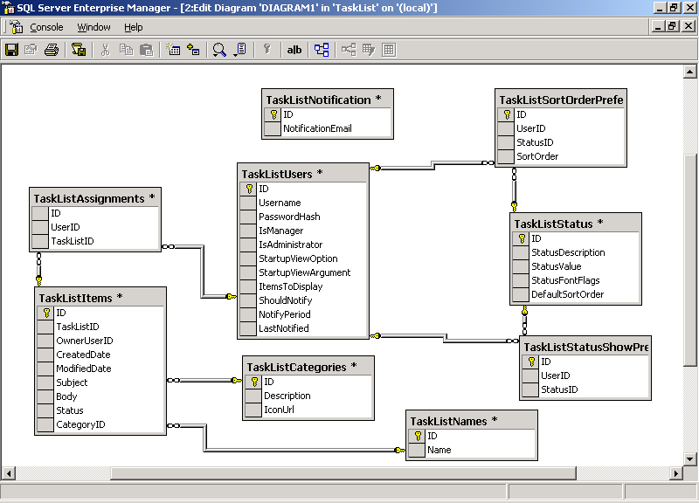

DATAFLOW DIAGRAMS:

A data flow diagram is graphical tool used to describe and analyze movement of data through a system. These are the central tool and the basis from which the other components are developed. The transformation of data from input to output, through processed, may be described logically and independently of physical components associated with the system. These are known as the logical data flow diagrams. The physical data flow diagrams show the actual implements and movement of data between people, departments and workstations. A full description of a system actually consists of a set of data flow diagrams. Using two familiar notations Yourdon, Gane and Sarson notation develops the data flow diagrams. Each component in a DFD is labeled with a descriptive name. Process is further identified with a number that will be used for identification purpose. The development of DFD’s is done in several levels. Each process in lower level diagrams can be broken down into a more detailed DFD in the next level. The lop-level diagram is often called context diagram. It consists a single process bit, which plays vital role in studying the current system. The process in the context level diagram is exploded into other process at the first level DFD.

The idea behind the explosion of a process into more process is that understanding at one level of detail is exploded into greater detail at the next level. This is done until further explosion is necessary and an adequate amount of detail is described for analyst to understand the process.

Larry Constantine first developed the DFD as a way of expressing system requirements in a graphical from, this lead to the modular design.

A DFD is also known as a “bubble Chart” has the purpose of clarifying system requirements and identifying major transformations that will become programs in system design. So it is the starting point of the design to the lowest level of detail. A DFD consists of a series of bubbles joined by data flows in the system.
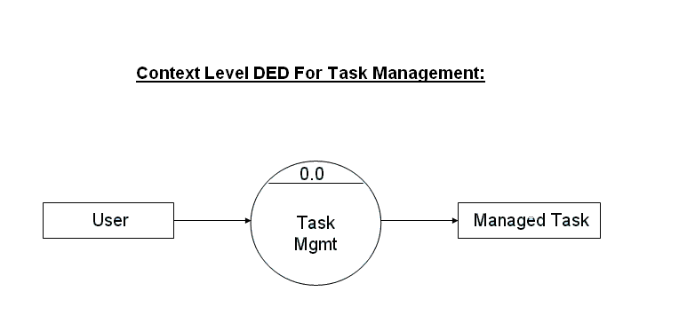

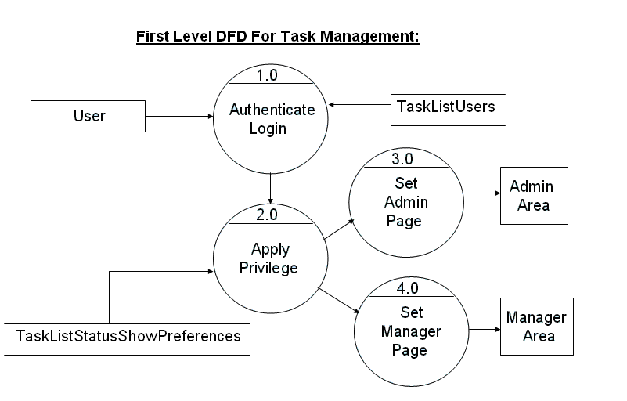

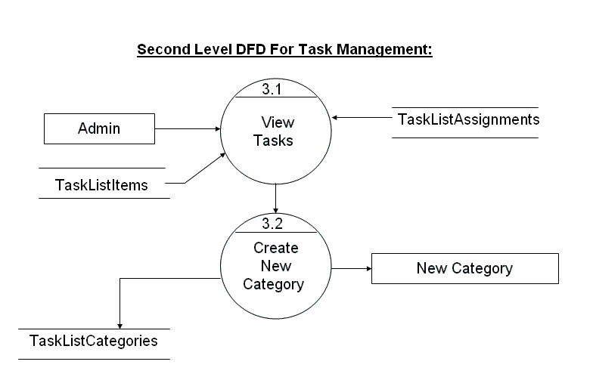

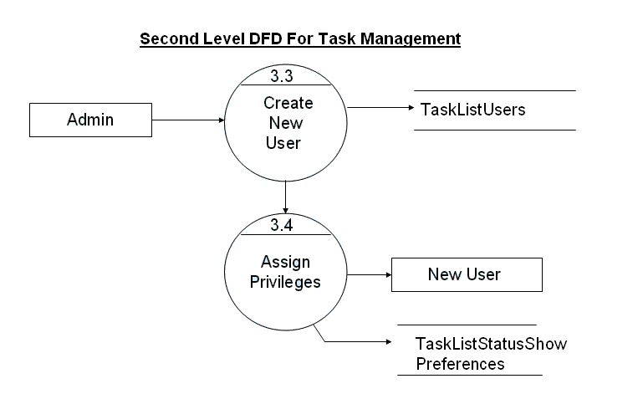
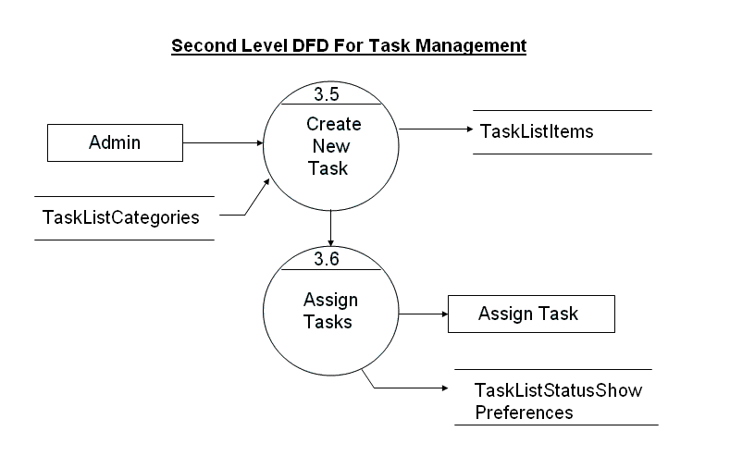
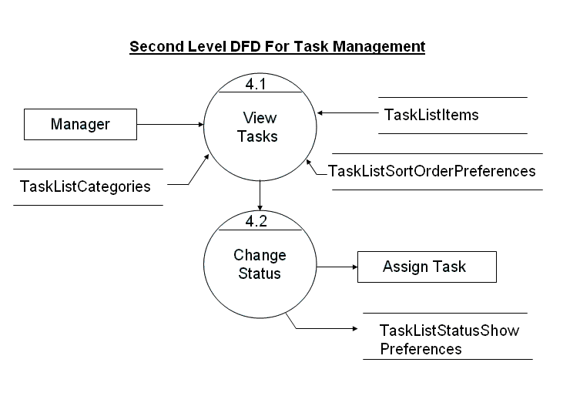

DATA DICTIONARY:

Task list Assignments

S.No | Column Name | Data Type | Description
1 | ID | bigInt(8)
2 | UserId | BigInt(8)
3 | TaskListId | BigInt(8)

Task List Categories

S.No | Column Name | Data Type | Description
1 | ID | Binint(8)
2 | Description | Varchar(50)
3 | IconUrl | Varchar(500)

Task List Items

S.No | Column Name | Data Type | Description
1 | ID | BigInt(9)
2 | TasklistID | Bigint(9)
3 | OwnerUserId | Bigint(9)
4 | CreatedDate | Datetime
5 | ModifiedDate | Datetime
6 | Subject | Varchar(255) | Allow Null
7 | Body | Varchar(5000) | Allow Null
8 | Status | Int(4)
9 | CategoryID | BigInt(8) | Allow Null

Task List Names

S.No | Column Name | Data Type | Description
1 | ID | BigInt(9)
2 | Name | Varchar(255)

Task List Notifications:

S.No | Column Name | Data Type | Description
1 | ID | Bigint(9)
2 | NotificationEmail | Varchar(5000)

Task list Sort Order Preferences

S.No | Column Name | Data Type | Description
1 | ID | Bigint(9)
2 | UserId | Bigint(9)
3 | StatusID | BigInt(9)
4 | SortOrder | Int(4)

Task list Status

S.No | Column Name | Data Type | Description
1 | ID | Bigint(9)
2 | Status Description | Varchar(50)
3 | StatusValue | Int(4)
4 | StatusFontFlag | Varchar(500)
5 | DefaultSortOrder | Int(4)

Task list Show Preferences

S.No | Column Name | Data Type | Description
1 | ID | Bigint(9)
2 | UserId | Bigint(9)
3 | StatusID | BigInt(9)

Task list Users

S.No | Column Name | Data Type | Description
1 | ID | Bigint(9)
2 | UserName | Varchar(50)
3 | PasswordHash | Varchar(50)
4 | IsManager | Bit
5 | IsAdministrator | Bit
6 | StartupViewOption | Varchar(20)
7 | StartupViewArgument | Bigint(8)
8 | ItemstoDisplay | Varchar(20)
9 | ShouldNotify | Bit
10 | Notify Period | Int (4)
11 | LastNotified | Datetime

5. UML DIAGRAMS
  - The unified modelling language allows the software engineer to express an analysis model using the modelling notation that is governed by a set of syntactic semantic and pragmatic rules.
  - A UML system is represented using five different views that describe the system from distinctly different perspective. Each view is defined by a set of diagram, which is as follows.

User Model View
    - This view represents the system from the users perspective.
    - The analysis representation describes a usage scenario from the end-users perspective.

Structural model view
◆ In this model the data and functionality are arrived from inside the system.
◆ This model view models the static structures.
Behavioural Model View
◆ It represents the dynamic of behavioural as parts of the system, depicting the interactions of collection between various structural elements described in the user model and structural model view.

Implementation Model View
  - In this the structural and behavioural as parts of the system are represented as they are to be built.
Environmental Model View
In this the structural and behavioural aspects of the environment in which the system is to be implemented are represented.

UML is specifically constructed through two different domains they are
- UML Analysis modeling, which focuses on the user model and structural model views of the system.
- UML design modeling, which focuses on the behavioral modeling, implementation modeling and environmental model.

Advantages Of Using UML:

As the name suggests UNIFIED MODELING LANGUAGE. Modeling has been around for years, not only in software field but also in other trades like civil, mechanical etc.example in civil engineering drawing the main architecture built of diagram is a model by itself. Modelling makes a complex and huge system to break up in to simple and discrete pieces that can be individually understood. Example simple flow drawing is modeling.

There are two main advantages of modeling:

- Readability: Representing your whole architecture in flowchart, class diagrams, ER diagrams etc makes your project more readable. Especially when programmers change jobs handover becomes easier. More the project is not readable more the dependencies.
- Reusability: After the system is more readable and broken down into pieces, it becomes easier to identify redundant and similar modules. Thus increasing reusability.

Use Case Diagrams
Use cases model the system from the end users point of view, with the following objectives
  - To define the functional and operational requirements of the system by defining a scenario of usage.
  - To provide a class and unambiguous description of how the end user and the system interact with one another.
  - To provide a basis for validation testing.
Use Cases
The actors who have been recognized within the system are
- Administrator
- Task Scheduler
Usecase Diagrams:
Administrator:

Administrator is the actor who is the authorized person within the system and is responsible for maintaining all the activities within the system.

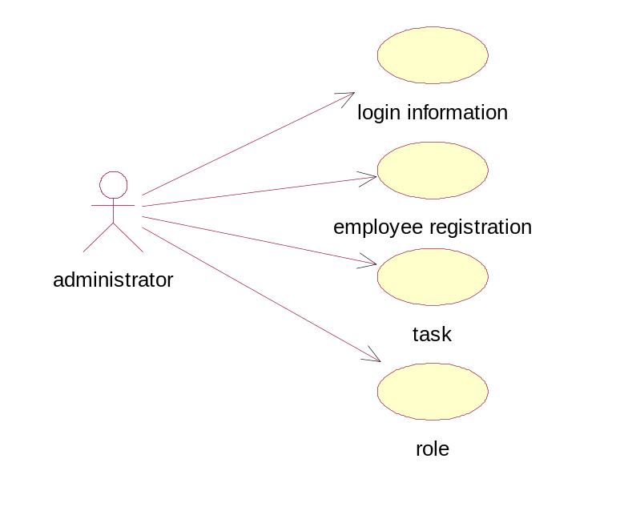

Task Scheduler:

Task Scheduler is a person who has all the privileges to schedule the task upon the existing employees responsible for monitoring the tasks that are scheduled.

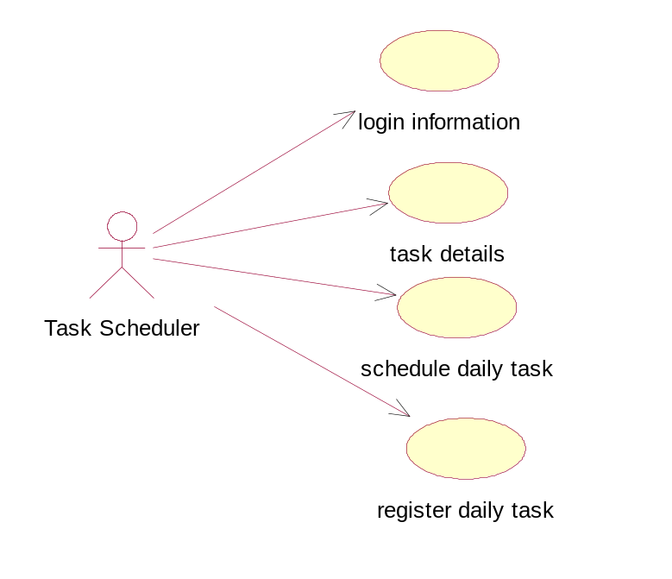

Sequence Diagrams:

1. Login Sequence

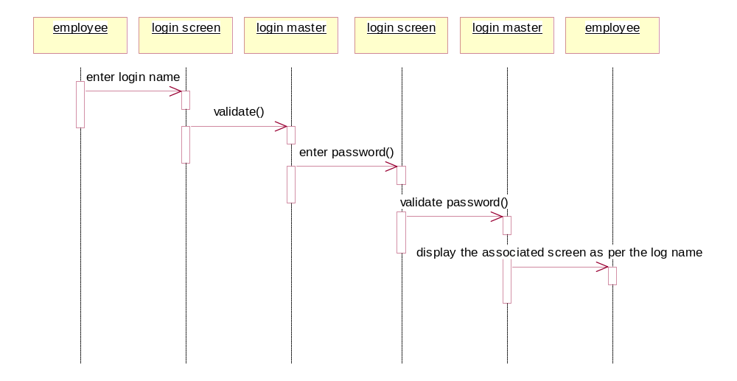

2. Task Scheduling Sequence

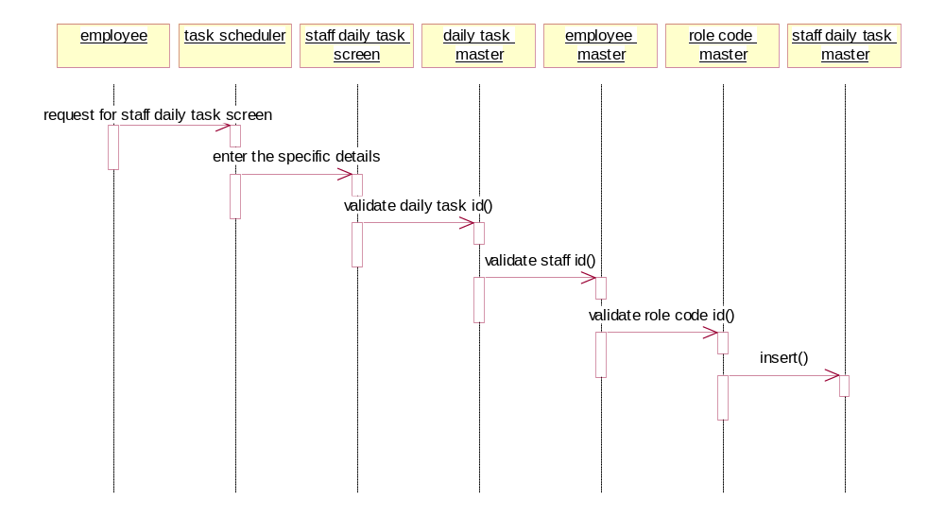

6. CODING

Program Design Language

    - The program design language is also called as structured English or pseudopodia. PDL is a generic reference for a design language PDL looks like a modern language. The difference between PDL and real programming language lies in the narrative text embedded directly within PDL statements.
The characteristics required by a design language are:
- A fixed system of keywords that provide for all structured constructs date declaration and modularity characteristics.
- A free syntax of natural language that describes processing features.
- Date declaration facilities that should include both simple and complex data structures.
- Subprogram definition and calling techniques that support various nodes of interface description.

PDL syntax should include constructs for subprogram definition, interface description date declaration techniques for structuring, conditions constructs, repetition constructs and I/O constructs.

PDL can be extended to include keywords for multitasking and/or concurrent processing interrupt handling, interposes synchronization the application design for which PDL is to be used should dictate the final form for the design language.

7. TESTING AND DEBUGGING STRATEGIES
Testing
Testing is the process of detecting errors. Testing performs a very critical role for quality assurance and for ensuring the reliability of software. The results of testing are used later on during maintenance also.

Psychology of Testing
The aim of testing is often to demonstrate that a program works by showing that it has no errors. The basic purpose of testing phase is to detect the errors that may be present in the program. Hence one should not start testing with the intent of showing that a program works, but the intent should be to show that a program doesn’t work. Testing is the process of executing a program with the intent of finding errors.

Testing Objectives
The main objective of testing is to uncover a host of errors, systematically and with minimum effort and time. Stating formally, we can say,
  - Testing is a process of executing a program with the intent of finding an error.
  - A successful test is one that uncovers an as yet undiscovered error.
  - A good test case is one that has a high probability of finding error, if it exists.
  - The tests are inadequate to detect possibly present errors.
  - The software more or less confirms to the quality and reliable standards.

Levels of Testing
In order to uncover the errors present in different phases we have the concept of levels of testing. The basic levels of testing are as shown below…

Acceptance Testing
System Testing
Integration Testing
Unit Testing
Client Needs

Requirements

Design

Code

System Testing
The philosophy behind testing is to find errors. Test cases are devised with this in mind. A strategy employed for system testing is code testing.

Code Testing:
This strategy examines the logic of the program. To follow this method we developed some test data that resulted in executing every instruction in the program and module i.e. every path is tested. Systems are not designed as entire nor are they tested as single systems. To ensure that the coding is perfect two types of testing is performed or for that matter is performed or that matter is performed or for that matter is performed on all systems.

Types Of Testing
- Unit Testing
- Link Testing

Unit Testing
Unit testing focuses verification effort on the smallest unit of software i.e. the module. Using the detailed design and the process specifications testing is done to uncover errors within the boundary of the module. All modules must be successful in the unit test before the start of the integration testing begins.
In this project each service can be thought of a module. There are so many modules like Login, HWAdmin, MasterAdmin, Normal User, and PManager. Giving different sets of inputs has tested each module. When developing the module as well as finishing the development so that each module works without any error. The inputs are validated when accepting from the user.
In this application developer tests the programs up as system. Software units in a system are the modules and routines that are assembled and integrated to form a specific function. Unit testing is first done on modules, independent of one another to locate errors. This enables to detect errors. Through this errors resulting from interaction between modules initially avoided.

Link Testing

Link testing does not test software but rather the integration of each module in system. The primary concern is the compatibility of each module. The Programmer tests where modules are designed with different parameters, length, type etc.

Integration Testing

After the unit testing we have to perform integration testing. The goal here is to see if modules can be integrated proprerly, the emphasis being on testing interfaces between modules. This testing activity can be considered as testing the design and hence the emphasis on testing module interactions.
In this project integrating all the modules forms the main system. When integrating all the modules I have checked whether the integration effects working of any of the services by giving different combinations of inputs with which the two services run perfectly before Integration.

System Testing

Here the entire software system is tested. The reference document for this process is the requirements document, and the goal os to see if software meets its requirements.
Here entire ‘ATM’ has been tested against requirements of project and it is checked whether all requirements of project have been satisfied or not.

Acceptance Testing

Acceptance Test is performed with realistic data of the client to demonstrate that the software is working satisfactorily. Testing here is focused on external behavior of the system; the internal logic of program is not emphasized.
In this project ‘Network Management Of Database System’ I have collected some data and tested whether project is working correctly or not.
Test cases should be selected so that the largest number of attributes of an equivalence class is exercised at once. The testing phase is an important part of software development. It is the process of finding errors and missing operations and also a complete verification to determine whether the objectives are met and the user requirements are satisfied.

White Box Testing
This is a unit testing method where a unit will be taken at a time and tested thoroughly at a statement level to find the maximum possible errors. I tested step wise every piece of code, taking care that every statement in the code is executed at least once. The white box testing is also called Glass Box Testing.
I have generated a list of test cases, sample data, which is used to check all possible combinations of execution paths through the code at every module level.

Black Box Testing
This testing method considers a module as a single unit and checks the unit at interface and communication with other modules rather getting into details at statement level. Here the module will be treated as a block box that will take some input and generate output. Output for a given set of input combinations are forwarded to other modules.

Criteria Satisfied by Test Cases
        - Test cases that reduced by a count that is greater than one, the number of additional test cases that much be designed to achieve reasonable testing.
        - Test cases that tell us something about the presence or absence of classes of errors, rather than an error associated only with the specific test at hand.
8. OUTPUT SCREENS

Installation
    - The database as it is developed by MS SQL Server 2000 can be installed only by using the export and import concepts.
    - Using .NET components like ASP.NET and VB.NET needs proper deployment as per general specifications developed.

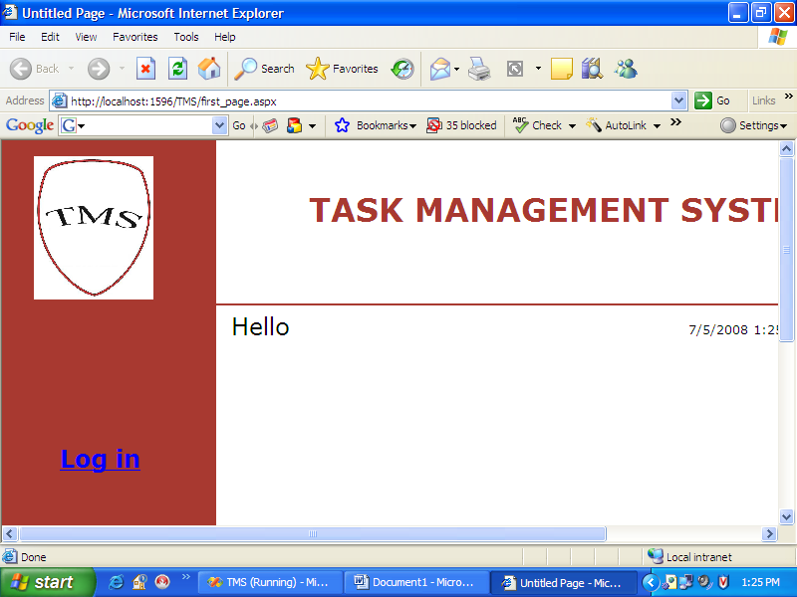

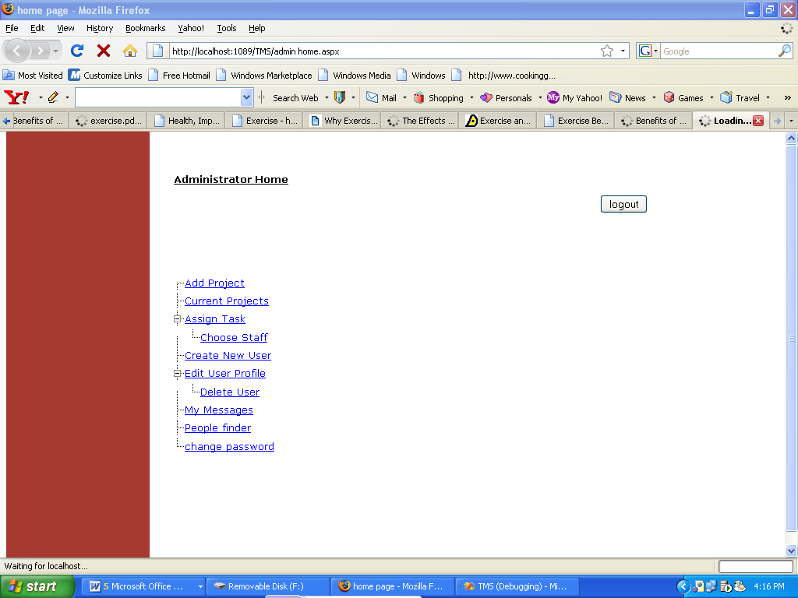

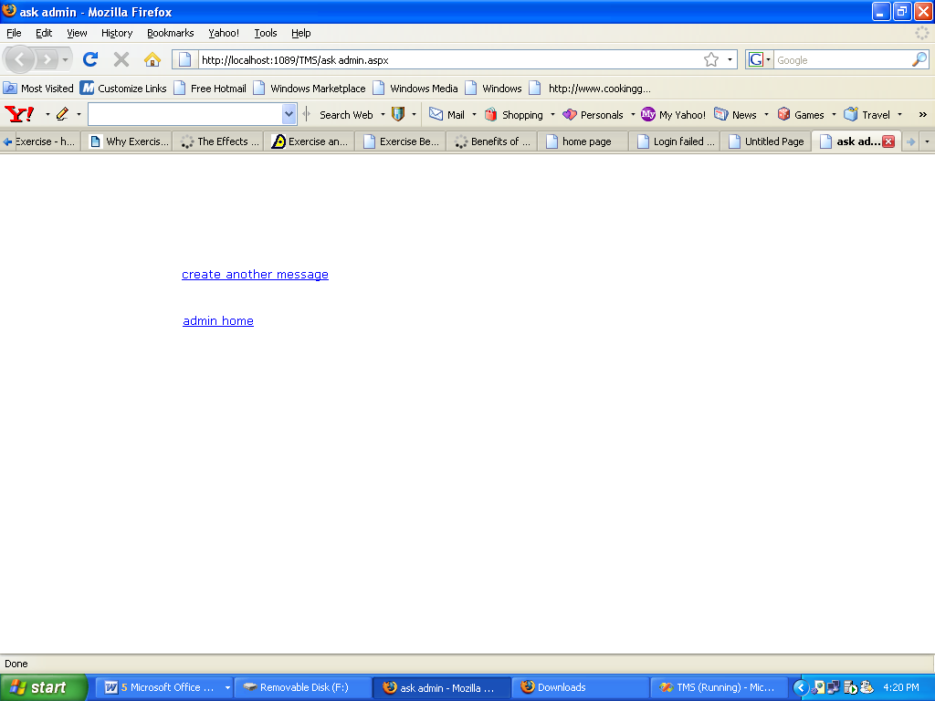

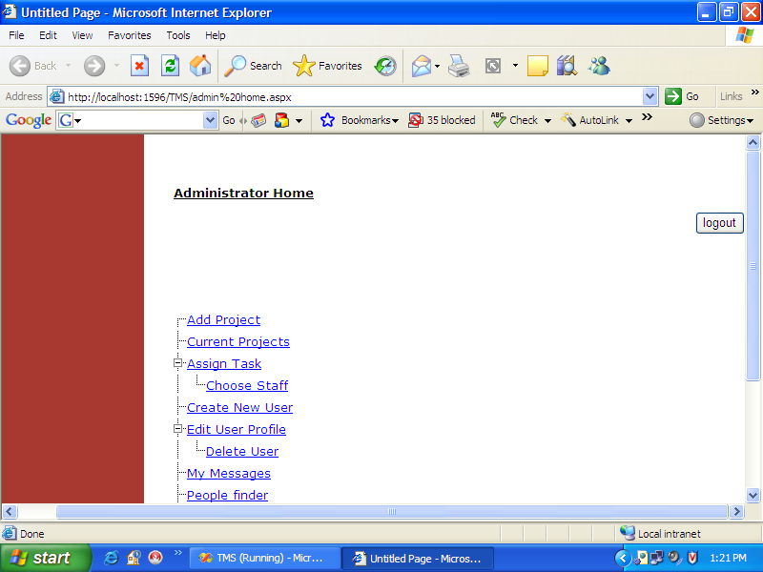

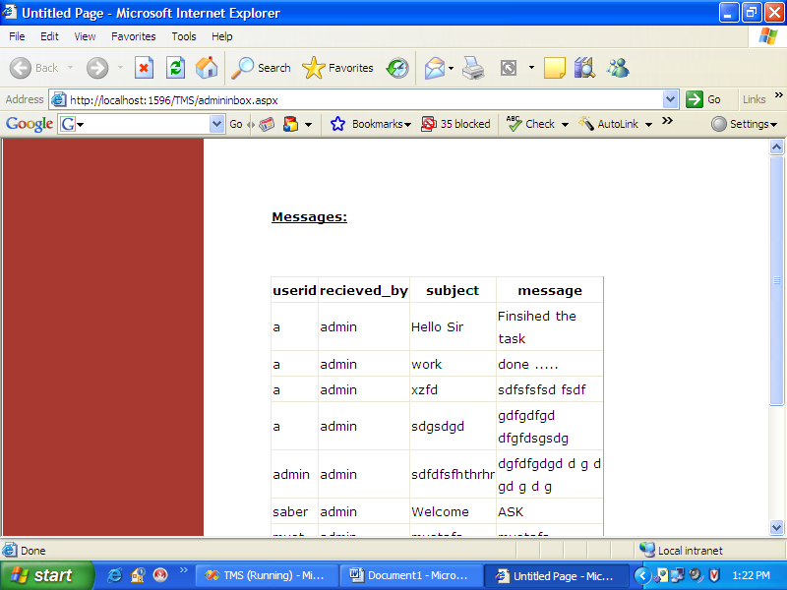

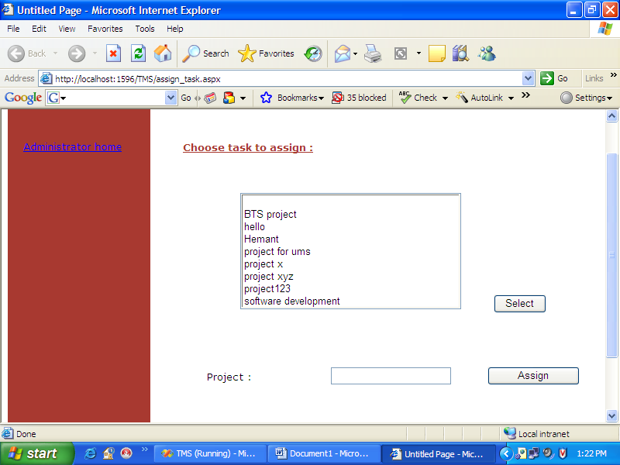

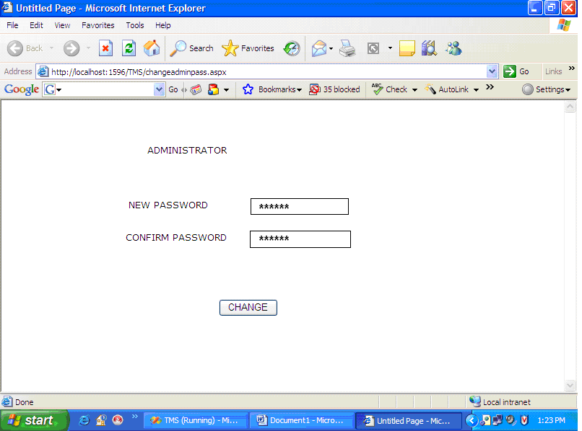

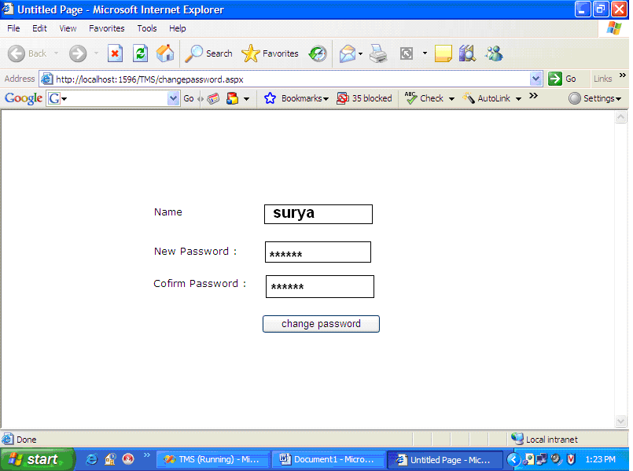

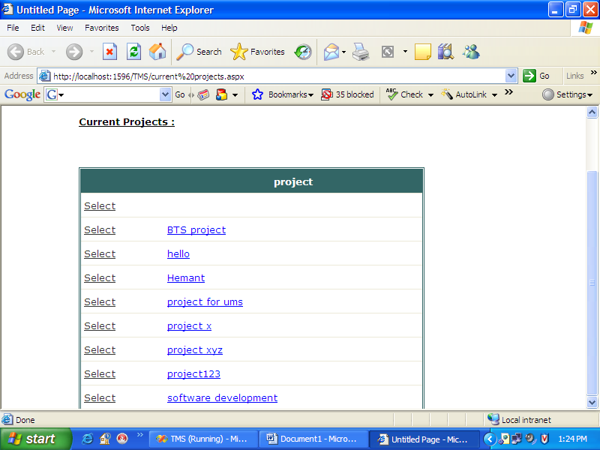

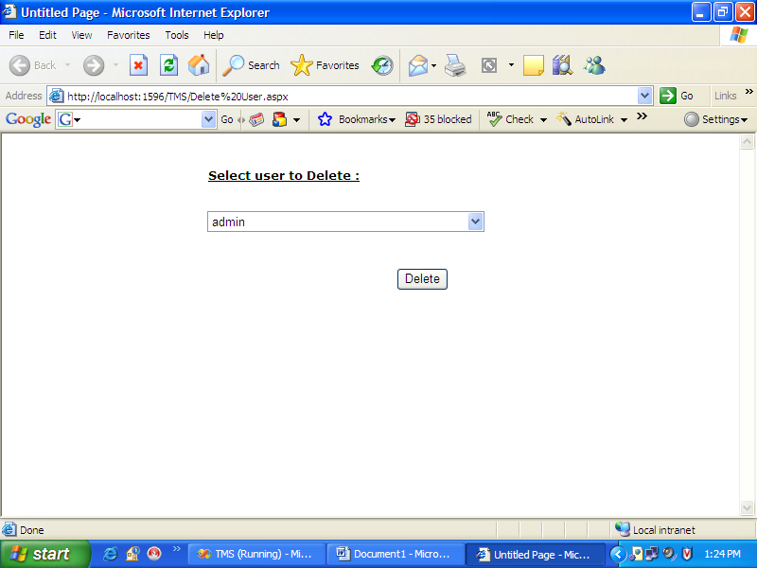

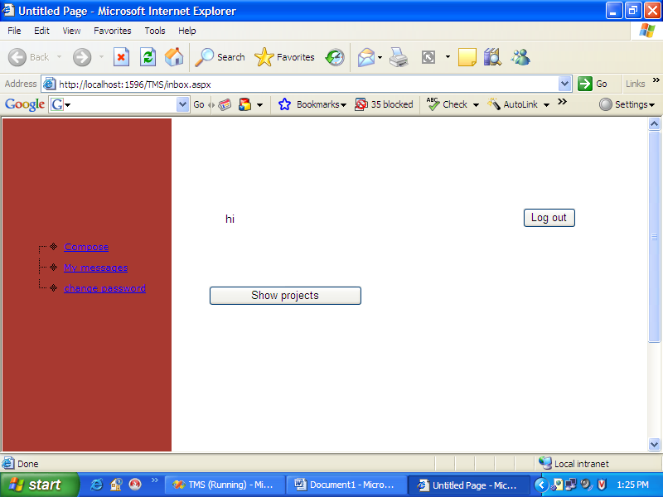

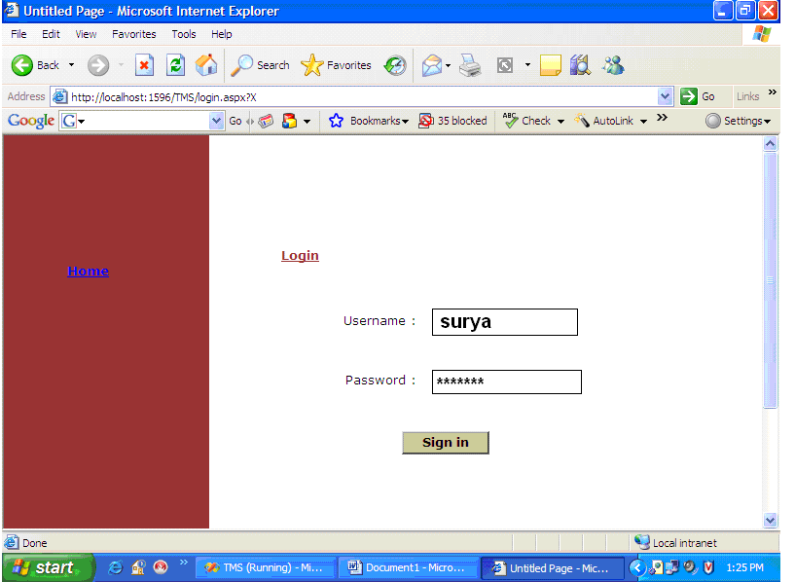

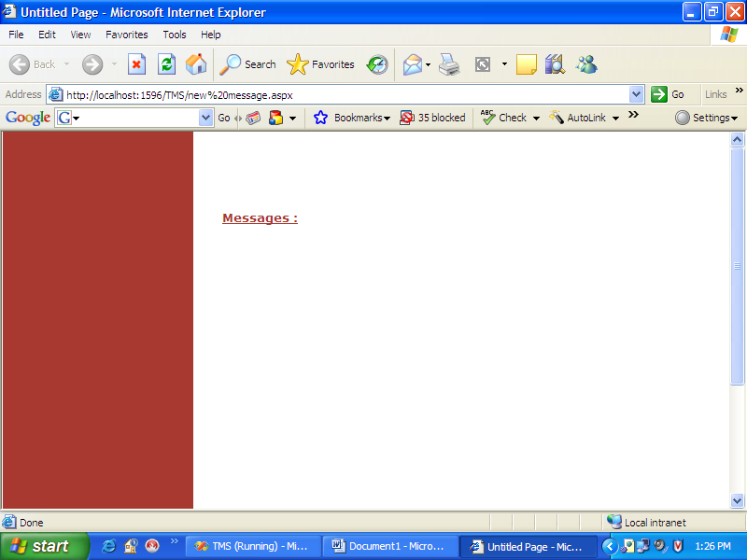

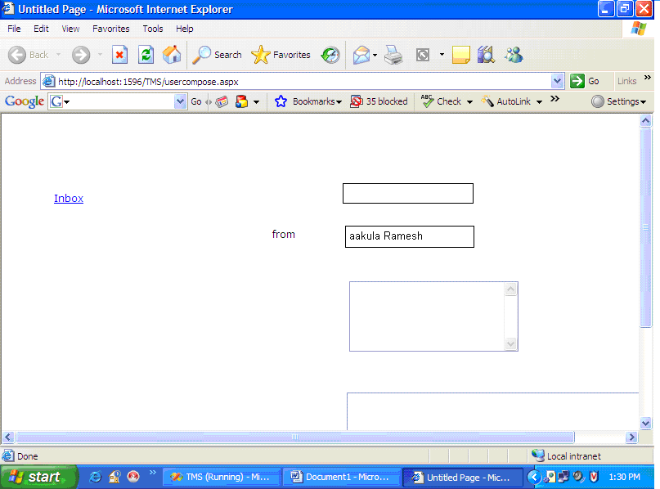

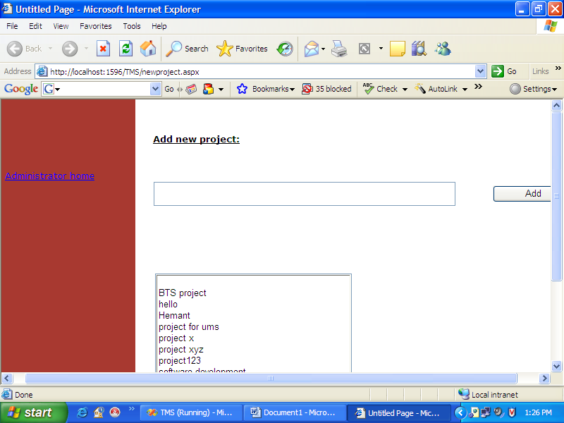

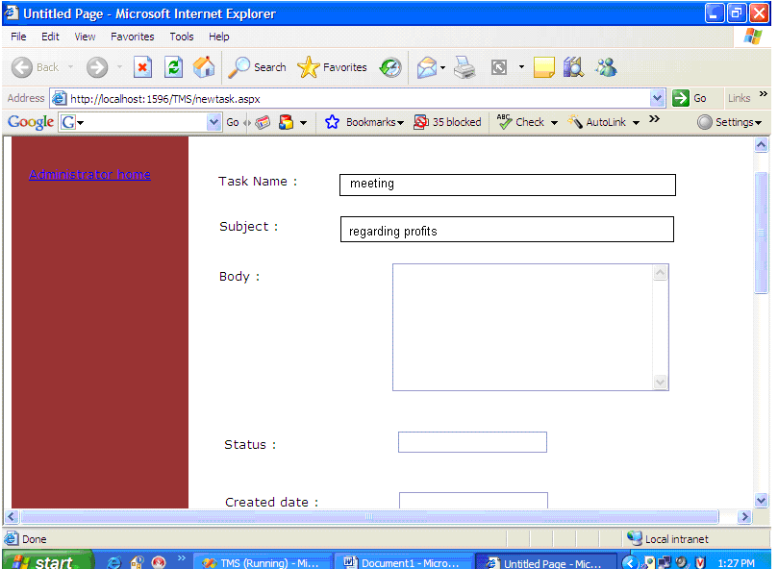

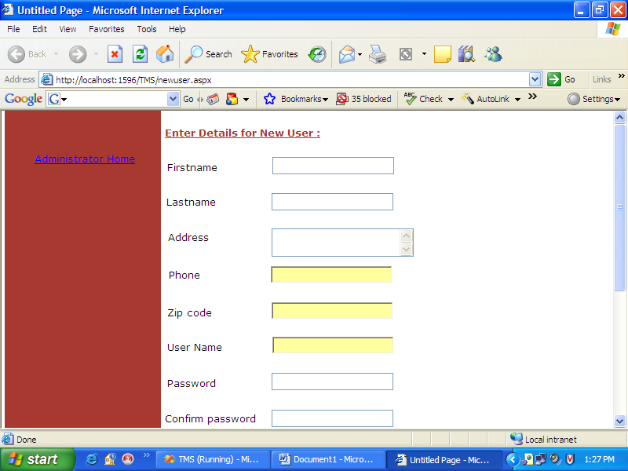

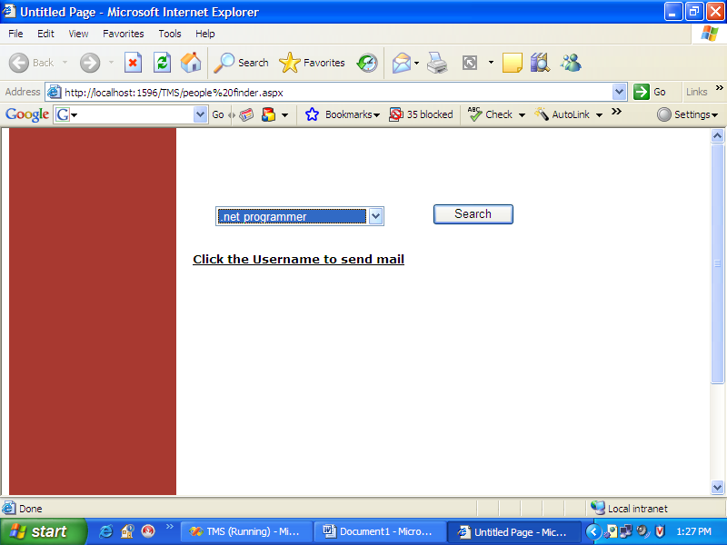

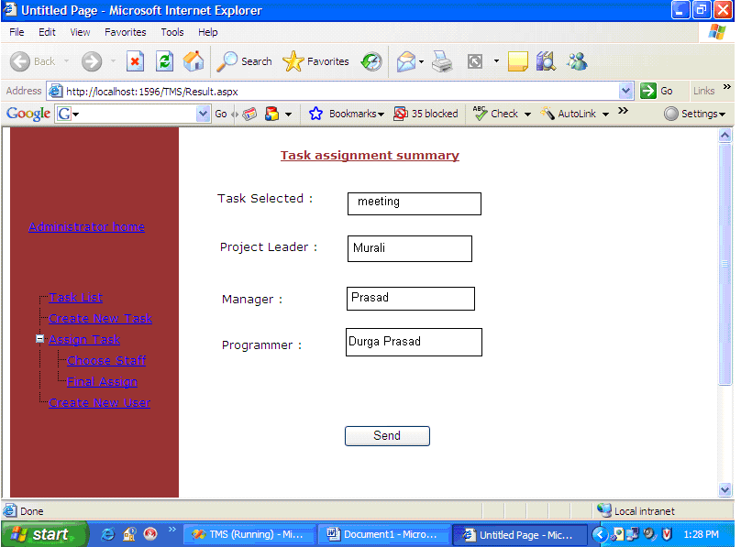

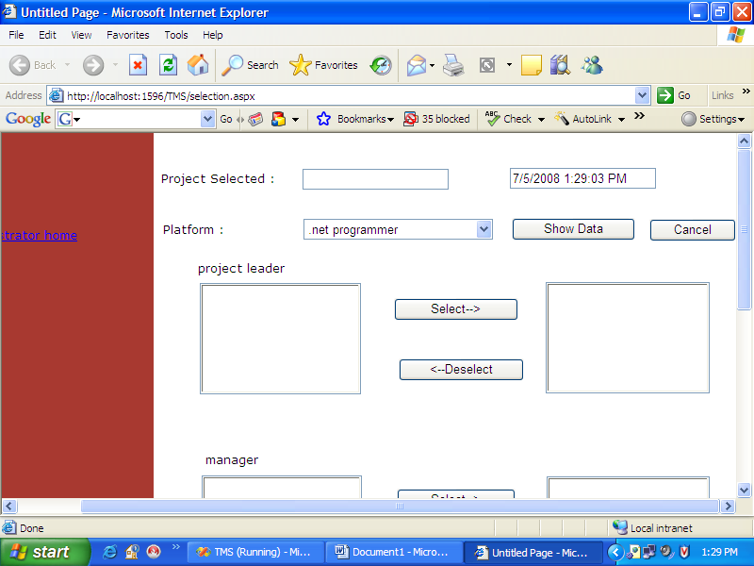

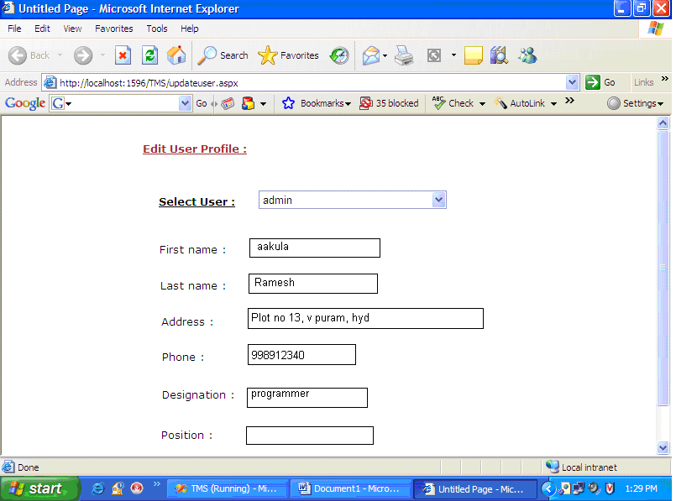

9. CONCLUSION

- The project has been appreciated by all the users in the organization.
- It is easy to use, since it uses the GUI provided in the user dialog.
- User friendly screens are provided.
- The usage of software increases the efficiency, decreases the effort.
- It has been efficiently employed as a Task management mechanism.
- It has been thoroughly tested and implemented.

10. BIBLIOGRAPHY

SOFTWARE ENGINEERING
By Roger.S. Pressman

SQL FOR PROFESSIONALS
By Jain

VISUAL BASIC.NET Black Book
By Evangeleous Petereous

ASP.Net Professional
By Wrox Publications

MSDN 2002
By Microsoft

